**STLC:** Just like complete team follows the [**Software Development Life Cycle (SDLC)**](http://tryqa.com/what-are-the-software-development-life-cycle-sdlc-phases/) likewise testers also follow the **Software Testing Life Cycle** which is called as **STLC**. It is the sequence of activities carried out by the testing team from the beginning of the project till the end of the project. A [**good software tester**](http://tryqa.com/software-tester/) is expected to have good knowledge of the STLC lifecycle and its activities.

**STLC Life cycle**

* There are 6 phases in the Software Testing Life Cycle or STLC life cycle.
* STLC is a testing process which is executed in a sequence, in order to meet the quality goals.
* It is not a single activity but it consists of many different activities which are executed to achieve a good quality product.
* STLC is followed by the testing team.
* STLC is similar to the SLDC, following a similar path and can run in parallel to the SDLC.

**STLC Phases**

There are different phases in STLC which are given below. The testing activities start from the Requirements analysis phase and goes through all the phases one by one before completing with the Test cycle closure phase.

* There are 6 STLC Phases in the STLC Lifecycle
* The entry criteria must be fulfilled before each phase can start
* The exit criteria should be fulfilled before exiting a phase
* Every phase has one or more deliverables that are produced at the end of the phase
* The phases are executed in a sequence

The **6 STLC Phases are given below**:

1. Requirement analysis
2. Test Planning
3. Test case development
4. Environment Setup
5. Test Execution
6. Test Cycle Closure

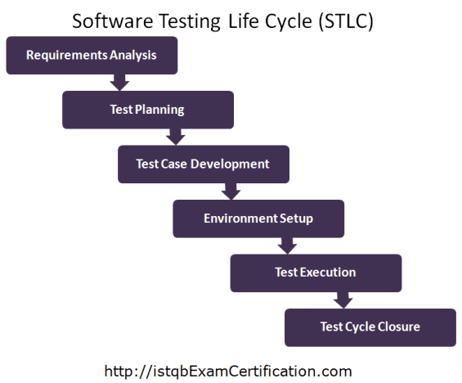

Each of the step mentioned above has some Entry Criteria (it is a minimum set of conditions that should be met before starting the software testing) as well as Exit Criteria (it is a minimum set of conditions that should be completed in order to stop the software testing) on the basis of which it can be decided whether we can move to the next phase of Testing Life cycle or not.

**STLC Life Cycle Phase Details**

Let us discuss about each phase of the STLC Life Cycle in detail. The STLC lifecycle can run in parallel or overlaps with the project life cycle.

**Requirement Analysis**

This is the very first phase of Software testing Life cycle (STLC). In this phase testing team goes through the Requirement document with both Functional and non-functional details in order to identify the testable requirements.

In case of any confusion the QA team may setup a meeting with the clients and the stakeholders (Technical Leads, Business Analyst, System Architects and Client etc.) in order to clarify their doubts.

Once the QA team is clear with the requirements they will document the acceptance Criteria and get it approved by the Customers.

**Activities** to be done in Requirement analysis phase are given below:

* Analyzing the System Requirement specifications from the testing point of view
* Preparation of RTM that is Requirement Traceability Matrix
* Identifying the testing techniques and testing types
* Prioritizing the feature which need focused testing.
* Analyzing the Automation feasibility.
* Identifying the details about the testing environment where actual testing will be done.

**Deliverables** (Outcome) of Requirement analysis phase are:

* Requirement Traceability Matrix (RTM)
* Automation feasibility report

Test Planning

[**Test Planning**](http://tryqa.com/what-is-the-purpose-and-importance-of-test-plans/) phase starts soon after the completion of the Requirement Analysis phase. In this phase the QA manager or QA Lead will [**prepare the Test Plan**](http://tryqa.com/what-things-to-keep-in-mind-while-planning-tests/) and [**Test strategy**](http://tryqa.com/what-are-the-test-approaches-or-strategies-in-software-testing/) documents. As per these documents they will also come up with the testing effort estimations.

**Activities** to be done in Test Planning phase are given below:

* Estimation of testing effort
* Selection of Testing Approach
* Preparation of Test Plan, Test strategy documents
* Resource planning and assigning roles and responsibility to them
* Selection of Testing tool

**Deliverables** (Outcome) of Test Planning phase are:

* Test Plan document
* Test Strategy document
* Best suited Testing Approach
* Number of Resources, skill required and their roles and responsibilities
* Testing tool to be used

**Test Case Development**

In this phase the QA team write test cases. They also write scripts for automation if required. Verification of both the test cases and test scripts are done by peers. Creation of Test Data is done in this phase.

**Activities** to be done in Test Case Development phase are given below:

* Creation of test cases
* Creation of test scripts if required (Automation)
* Verification of test cases and automation scripts
* Creation of Test Data in testing environment

**Deliverables** (Outcome) of Test Case Development phase are:

* Test cases
* Test scripts (for automation if required)
* Test Data

**Test Environment setup**

This phase includes the setup or installation process of software and hardware which is required for testing the application. In this phase the integration of the third party application is also carried out if required in the project.

After setting up the required software and hardware the installation of build is tested. Once the installation of build is successful and complete then the Test Data is generated.

After the creation of Test data the Smoke testing is executed on the build in order to check whether the basic functionalities are working fine or not. This phase can be done in parallel with the Test Case Development phase.

**Activities** to be done in Test Environment Setup phase are given below:

* As per the Requirement and Architecture document the list of required software and hardware is prepared
* Setting up of test environment
* Creation of test data
* Installation of build and execution of Smoke testing on it

**Deliverables** (Outcome) of Test Environment Setup phase are:

* Test Environment setup is ready
* Test Data is created
* Results of Smoke testing

**Test Execution**

Before starting the Test Execution phase the Test Environment setup should be ready. In Test Execution phase the test cases are executed in the testing environment.

While execution of the test cases the QA team may find bugs which will be reported against that test case. This bug is fixed by the developer and is retested by the QA.

**Activities** to be done in Test Execution phase are given below:

* Execution of Test Cases
* Reporting test results
* Logging defects for the failed test cases
* Verification and retesting of the defect
* Closure of defects

**Deliverables** (Outcome) of Test Execution phase are:

* Test execution Report
* Updated test cases with results
* Bug Report

**Test Cycle Closure**

In order to start the Test Cycle Closure activity the Test Execution phase should be completed. In Test Cycle phase the QA team will meet and discuss about the testing artifacts.

The whole intent of this discussion is to learn lessons from the bad practices. This will help in future projects.

**Activities** to be done in Test Cycle Closure phase are given below:

* To evaluate the test completion on the basis of Test Coverage and Software Quality
* Documentation of the learning from the project
* Analyzing the test results to find out the distribution of severe defects
* Test Closure Report preparation

**Deliverables** (Outcome) of Test Cycle Closure phase are:

* Report of Test Closure

Entry & Exit Criteria For STLC Phases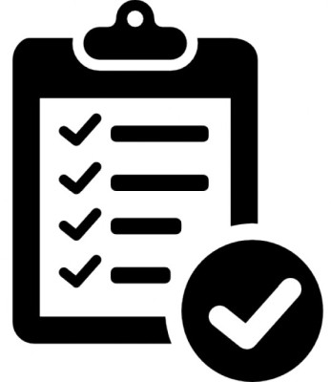

The below table briefly explains the Software Testing Life Cycle STLC along with the Entry Criteria, Activity, Exit Criteria and Deliverable associated with each phase:

**Requirement Analysis**

|  |  |  |
| --- | --- | --- |
| **Entry Criteria** | **Activity** | **Exit Criteria** |
| Availability of Requirement document both Functional as well as non-functional  Architectural document of the application or the product should be available  Acceptance criteria defined and duly signed by the customers | Analysis of System Requirement specifications to understand the different business modules and it’s functionalities  To identify the user profile, user interface and user authentication  Types of tests to be performed on the application or product should be identified  Should collect the details about testing priorities  Preparation of RTM that is Requirement Traceability Matrix  Test Environment details should be identified in order to do testing  Analysis of automation possibility if it is required | RTM should be signed off  The customer should sign off on the test automation feasibility |
| **Deliverables (Outcome) –**Requirement Traceability Matrix (RTM), Report on Automation Feasibility if it is applicable | | |

**Test Planning**

|  |  |  |
| --- | --- | --- |
| **Entry Criteria** | **Activity** | **Exit Criteria** |
| Detailed requirement document  Requirement Traceability Matrix (RTM)  Automation Feasibility Report | Preparation of Test Plan document  Preparation of Test strategy document  To analyze the best suited testing approach for the application or product  To analyze the testing techniques and the types of testing to be carried out in order to maintain the quality  Selection of the testing tool  Estimation on the testing efforts  Resource planning as per the skill required for testing and also assigning roles and responsibility to them | Approved Test Plan document  Approved Test Strategy document  Document of Effort estimation |
| **Deliverables (Outcome) –**Test Plan document, Test Strategy document, Effort estimation document | | |

**Test case development**

|  |  |  |
| --- | --- | --- |
| **Entry Criteria** | **Activity** | **Exit Criteria** |
| Detailed Requirement document  Test Plan and Test strategy documents  Automation Feasibility Report | Creation of test cases for all the modules or features in the application or product  Creation of automation scripts if required  Review of test cases and test automation scripts  Test data creation | Reviewed Test cases  Reviewed Test automation scripts  Test data creation ready for testing |
| **Deliverables (Outcome) –**Test cases, Test automation scripts, Test data | | |

**Test Environment Setup**

|  |  |  |
| --- | --- | --- |
| **Entry Criteria** | **Activity** | **Exit Criteria** |
| System design documents should be available  Architectural document of the application should be available  Environment set-up plan document should be available | Understanding the design and architecture of the application  Setting up the test environment  Installation of required hardware and software in order to start testing the application  Integration of any third party application (if required)  Installation of build  Creation of test data  Execution of smoke testing on the build  Accepting or rejecting the build as per the smoke test result | Environment setup is ready for testing  All the required software and hardware are installed  Build installation is complete and successful  Test data creation is complete  Smoke testing is done |
| **Deliverables (Outcome) –**Test environment along with test data, Smoke test result | | |

**Test Execution**

|  |  |  |
| --- | --- | --- |
| **Entry Criteria** | **Activity** | **Exit Criteria** |
| Documents like RTM, Test Plan, Test strategy, Test cases and Test scripts should be ready  Test environment should be ready  Test data should be ready  Integration of third party application (if required) should be successful  Smoke testing of the application should be successful | Execution of test cases  Preparation of test result document  Logging defects for the failed test cases  Mapping of defects with the test cases  To update the test cases and test strategy if required  Fixed defects should be retested  Closure of the defects if they are working as expected  Execution of regression testing of the application or product in order to ensure its stability post defect closure | All test cases are executed  Defects are logged and tracked for closure |
| **Deliverables (Outcome) –**Completed the test case execution, Updated the test cases wherever required, Defects reported | | |

**Test Cycle Closure**

|  |  |  |
| --- | --- | --- |
| **Entry Criteria** | **Activity** | **Exit Criteria** |
| All the test cases are executed and updated  Test results are documented  Defect logs are available | Evaluation of the test completion on the basis of Test Coverage and Software Quality  Preparation of Test Closure report  Analyzing the test results to find out the distribution of severe defects | Signed off Test Closure report by the client |
| **Deliverables (Outcome) –**Test closure Report | | |

STLC and SDLC

Software Testing Life Cycle STLC is very similar to the the Software Development Life Cycle SDLC.

* STLC is a segment or a subset or a part of the SDLC
* SDLC is used to plan and execute the development of the software project while the scope of STLC is limited to testing activities
* In both STLC and SDLC, the activities are executed one after the other
* Both STLC and SDLC phases have entry and exit criteria to be fulfilled before entering or leaving a phase

**Difference between – STLC vs SDLC**

When comparing  STLC vs SDLC there are some key differences that are observed.

|  |  |
| --- | --- |
| **SDLC** | **STLC** |
| Software Development Life Cycle – SDLC can be used for planning, implementation and release of the entire software development project | Software Testing Life Cycle governs only the testing and quality related activities of the project |
| SDLC is much larger than STLC | STLC is a part of SDLC |
| Development teams go through the requirements and analyze it to understand how to design, implement and architect it | QA teams analyze requirements from testing perspective to understand what needs to be tested, what kind of scenarios need to be tested, how the user will use the system and where they could face issues etc |
| Software development models and methodologies are decided in SDLC, project planning is done. Architecture and design are produced by the architect. | Model to be followed for testing is decided. Test plan and test strategy are finalized by the Test Manager and Test Lead. |
| Development teams work on the implementation and coding of the software | Testing team members work on developing test cases and test scripts |
| In development phase in SDLC, once development is completed on a feature, developers test the functionality they have developed, as part of unit testing | During test execution in STLC, testers test the entire application from end to end, testing all features and functionalities |
| Project closure activity has a wider scope since it looks at the over all project to evaluate the results of the project, getting project acceptance, documenting lessons learnt etc | Scope of the Test closure activities are limited to testing activities like evaluating test completion, preparing test closure report, analyzing test results, documenting / sharing lessons learnt etc. |